Waterfall:

The general idea behind the Waterfall SDLC is that it uses a linear development model that follows a step-by-step process for developing software. Only after a previous step in the lifecycle is completed will the next step begin. This makes the model easy to understand and is perfect for software systems where the requirements of the model are well understood in advance. One main disadvantage to the Waterfall model is that it is rather inflexible, which can make this process difficult for software development of a system whose requirements change throughout development.

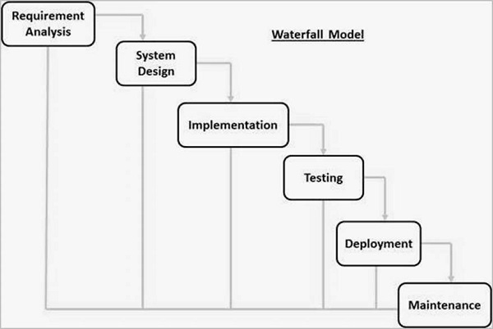

V-Model:

The V-Model SDLC is a variant of the Waterfall SDLC that incorporates the linear development cycle of the waterfall model. The main difference between the two models is that there is an emphasis on product verification. This emphasis is expressed with product testing that occurs in parallel with each phase of software development. Along with the advantages that come with the Waterfall SDLC, the V-Model is great for software designs that require high reliability. Frequent testing in each development phase helps ensure such reliability. However, this model is also an inflexible development cycle, making this model unsuitable for systems with changing requirements.

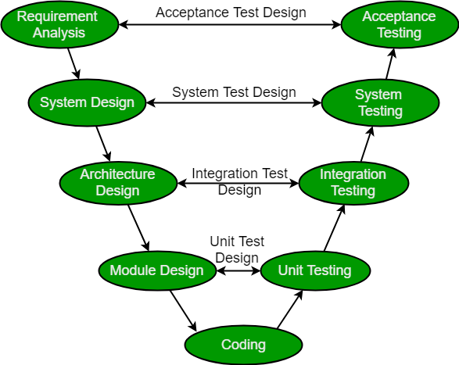

Sources:

<https://www.tutorialspoint.com/sdlc/sdlc_waterfall_model.htm>

<https://www.geeksforgeeks.org/software-engineering-sdlc-v-model/>